Hospital Management System
Project submitted to the
School of Engineering & Technology, BML Munjal University
for the partial fulfilment of the requirements to award the degree of
Bachelor of Technology
In
Computer Science and Engineering
School of Engineering and Technology
Submitted by
Aryan Gupta (240407)
Avyam Manchanda (240417)
Anmol Bhardwaj (240383)
Deepankar Vishnoi (240433)

Under the Guidance of
Dr. Nishtha Phutela
BML Munjal University
Kapriwas, Haryana– 122413
[May, 2026]

Certificate
Date: 11/28/2024
This is to certify that the work present in this Project entitled “Hospital ManagementSystem” has been carried out by
Aryan Gupta (240407)
Avyam Manchanda (240417)
Anmol Bhardwaj (240383)
Deepankar Vishnoi (240433)
under my/our supervision. The work is genuine, original, and suitable for submission to the BML Munjal University for the award of Bachelor of Technology in School of Engineering and Technology.

Supervisor
Prof. / Dr. Nishtha Phutela

Table of Contents
Sl.No. | Topic | Page No.
1 | Certificate | 2
2 | Table of Contents | 3
3 | Abstract | 4
4 | Abbreviations | 5
5 | List of Tables | 6
6 | List of Figures | 7
7 | Introduction | 8
8 | Problem Statement | 9
9 | Methodology | 10
10 | Discussion | 12
11 | Concluding Remarks | 13
12 | Societal Relevance | 13
13 | Future Scope | 14
14 | Team Details and Contribution | 14
15 | References | 15

Abstract (max 2 paragraphs)
This project presents a Hospital Management System designed to efficiently manage hospital operations such as patient records, doctor details, appointments, prescriptions, medicines, and billing. The system uses a relational database approach to ensure data consistency and integrity.
The system is implemented using Node.js, Express, and MySQL, providing secure REST APIs with JWT-based authentication. The effectiveness of the system is demonstrated through CRUD operations, appointment scheduling, and billing summaries. The results show that the system improves data organization, reduces redundancy, and enhances operational efficiency.

List of Tables
For Patient
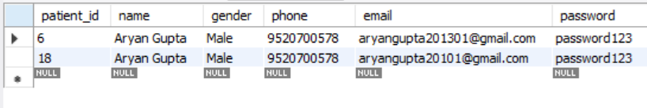

For Doctor
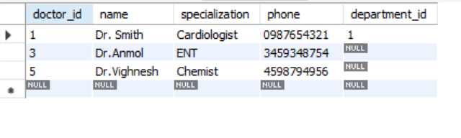
For Appointment
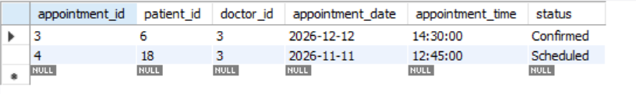

For Bill
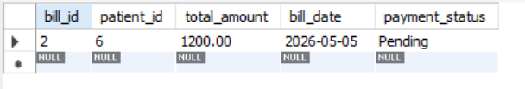
List of Figures

Figure 1: ER Diagram of Hospital Management System
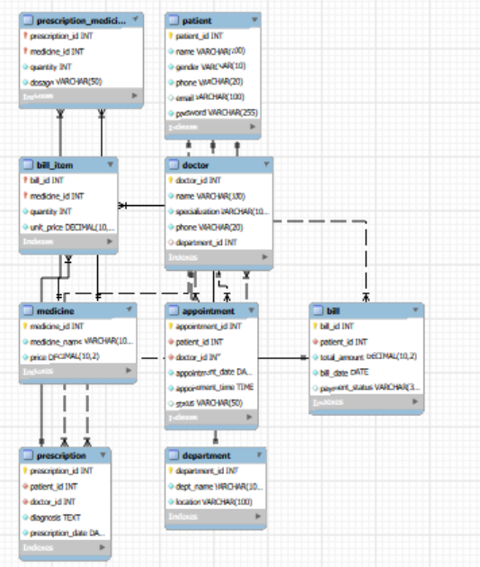

Figure 2: Front Page

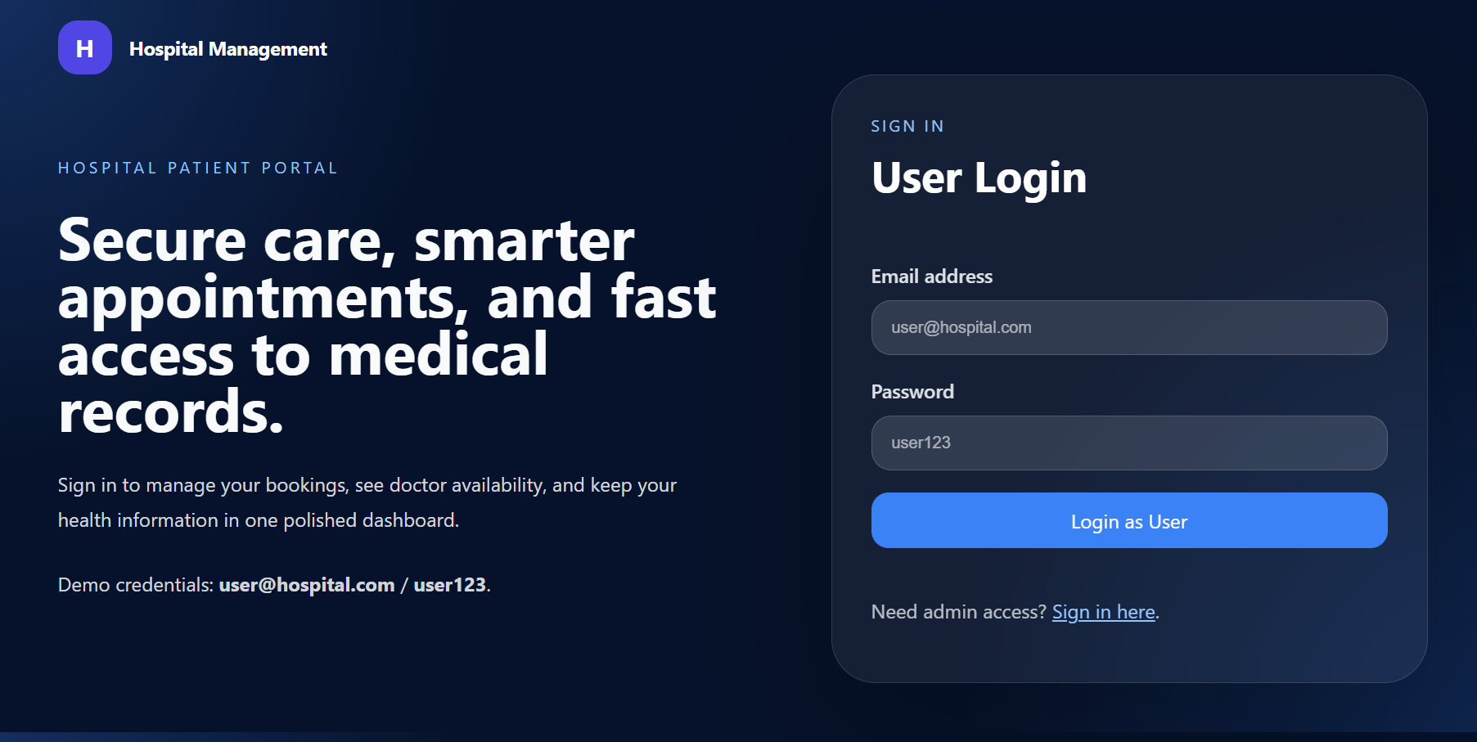

Figure 3: Admin Dashboard Interface

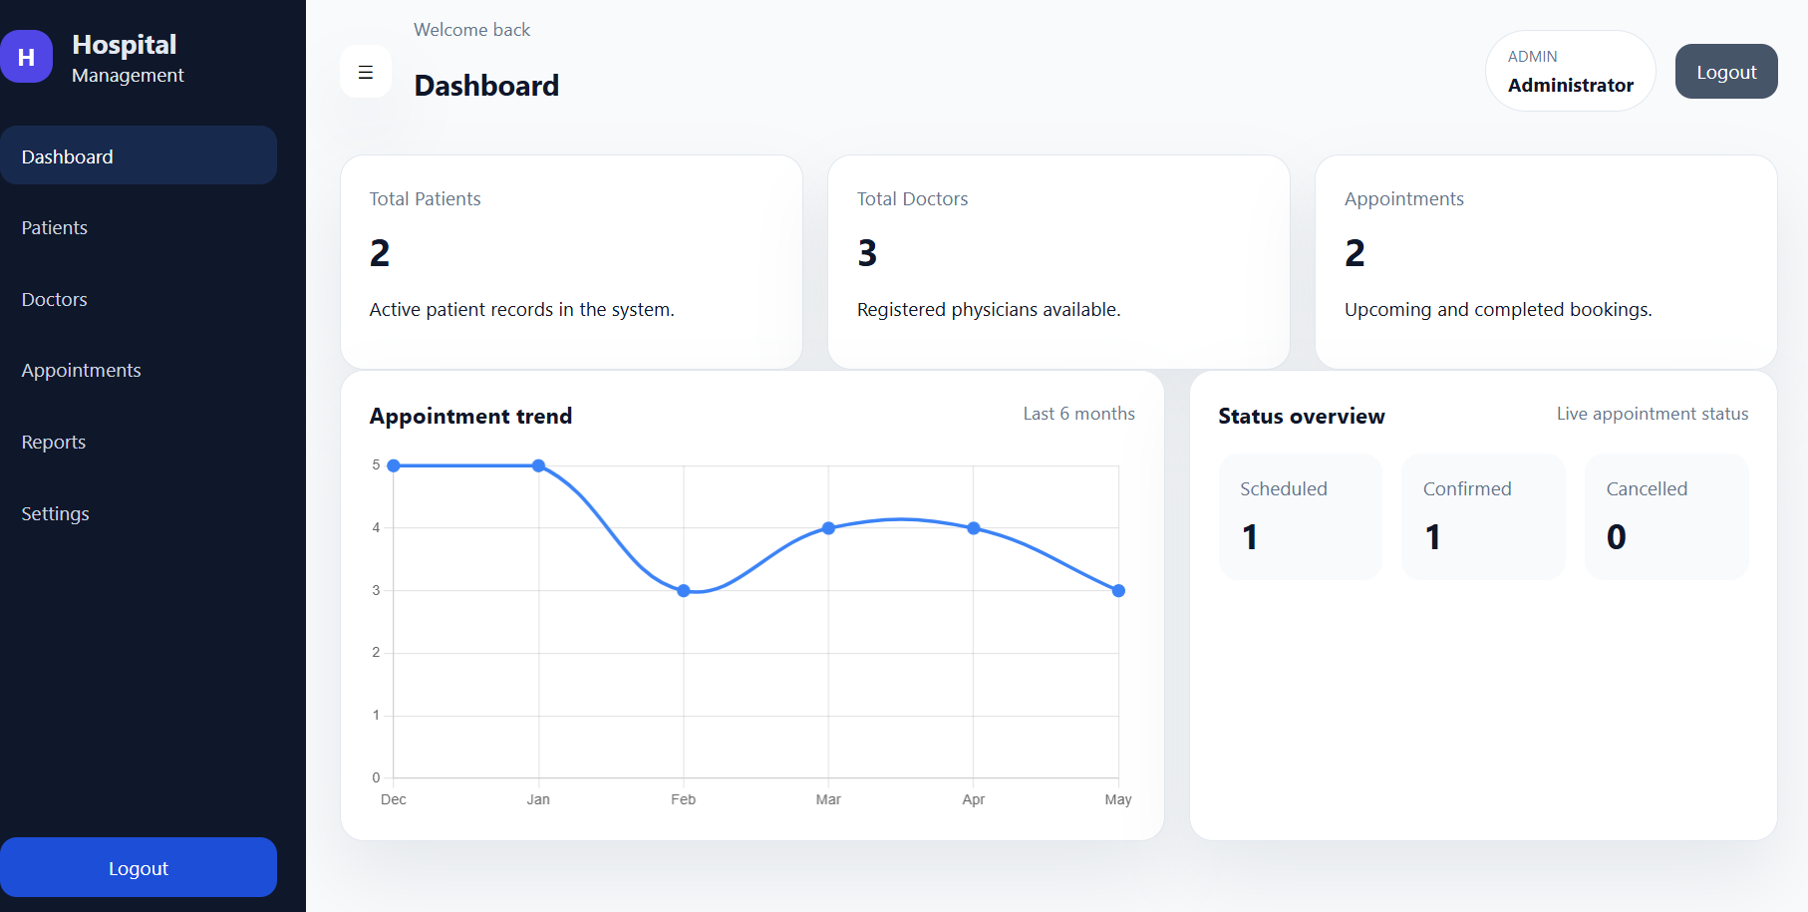

Introduction
With the rapid growth of digital technologies, the healthcare sector has increasingly adopted computerized systems to manage hospital operations. Hospitals handle large volumes of data such as patient records, doctor details, appointments, prescriptions, and billing information. Managing this data manually can lead to errors, inefficiencies, and data redundancy, making it necessary to develop an organized and reliable system.

The Hospital Management System (HMS) is designed to provide a centralized platform for managing all hospital-related activities efficiently. It uses a relational database to store and manage data, ensuring proper relationships between entities such as patients, doctors, departments, appointments, and bills. The system allows users to perform operations like booking appointments, generating prescriptions, and managing billing in a structured manner.

This project is implemented using Node.js, Express, and MySQL, along with secure authentication using JSON Web Tokens (JWT). It demonstrates key DBMS concepts such as normalization, referential integrity, and SQL queries. Overall, the system improves data accuracy, reduces manual effort, and enhances the efficiency of hospital management processes.

Methodology
- Design (ER Diagram, Schema, Normalization)

The system is designed using an Entity-Relationship (ER) model. The main entities include Patient, Doctor, Department, Appointment, Prescription, Medicine, and Bill.
Relationships:
Department → Doctor (1:N)
Doctor → Appointment (1:N)
Patient → Appointment (1:N)
Prescription → Medicine (M:N using junction table)

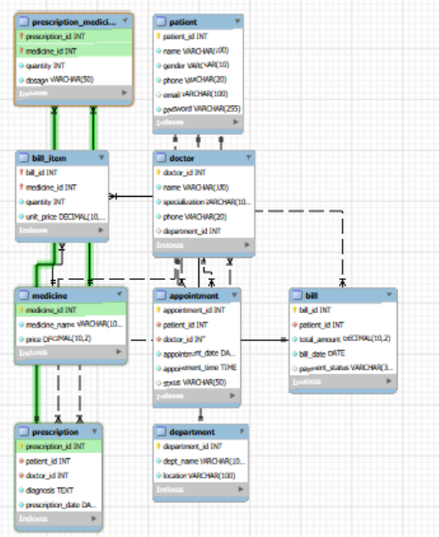

- Implementation
The backend is developed using Node.js and Express. MySQL is used as the relational database.
Features implemented:
JWT Authentication
CRUD APIs for all entities
Appointment booking system
Prescription management
Billing system with aggregation queries
The system uses middleware for authentication and role-based access.

- Algorithm:

Input: Patient and Doctor data
Output: Appointment, Prescription, and Bill records

Step 1: Authenticate user using JWT
Step 2: Store patient and doctor data
Step 3: Book appointment
Step 4: Generate prescription
Step 5: Calculate bill using SQL queries

- Discussion/Results/Observations
Sub heading:
The Hospital Management System was successfully implemented and tested using various real-time scenarios. The system efficiently handles operations such as adding patients, managing doctor records, booking appointments, generating prescriptions, and calculating bills. All modules are interconnected through a relational database, ensuring smooth data flow and consistency across the system.
The database operations make extensive use of SQL queries including SELECT, INSERT, UPDATE, and DELETE. To retrieve meaningful information, JOIN operations are used to combine data from multiple tables. For example, appointment details are fetched by joining the Patient and Doctor tables with the Appointment table to display patient names, doctor names, date, and status in a single result.
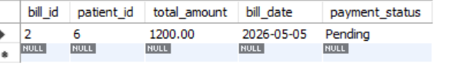

Concluding Remarks
The Hospital Management System developed in this project successfully demonstrates the practical application of database management concepts in a real-world scenario. The system integrates various modules such as patient management, doctor management, appointment scheduling, prescription handling, and billing into a single platform. By using a relational database, the system ensures data consistency, integrity, and efficient retrieval of information.
The implementation using Node.js, Express, and MySQL provides a scalable and secure backend architecture. Features such as JWT-based authentication and role-based access control enhance system security and reliability. The use of SQL queries, joins, aggregation functions, and constraints reflects a strong understanding of DBMS principles.
Overall, the project achieves its objective of simplifying hospital operations and reducing manual effort. It provides a structured and efficient way to manage hospital data, making it suitable for small to medium-scale healthcare environments.

Any societal relevance of your work
The Hospital Management System has significant societal importance as it contributes to improving the efficiency and quality of healthcare services. By digitizing patient records and hospital operations, the system reduces manual errors and ensures accurate data management. This leads to better decision-making by healthcare professionals and faster access to patient information during critical situations.
The system also enhances transparency and accountability in hospital processes such as appointment scheduling and billing. Patients benefit from organized records, quicker service, and improved communication with healthcare providers. Additionally, the use of secure authentication mechanisms helps protect sensitive medical data, ensuring privacy and trust.
In the broader context, such systems support the digital transformation of healthcare, making medical services more efficient, accessible, and reliable for society.

Future scope (how would you like to expand this, if any plan)
The current system provides a strong foundation for hospital data management; however, it can be further enhanced with additional features and technologies. One possible improvement is the development of a mobile application that allows patients to book appointments, view prescriptions, and track medical history from their smartphones.
The system can also be extended by integrating advanced technologies such as artificial intelligence for disease prediction and recommendation systems. Cloud deployment can improve scalability and allow access from multiple locations, making it suitable for larger hospital networks. Real-time notifications and integration with wearable health devices can further enhance patient monitoring.
Additionally, implementing advanced analytics and reporting tools can help hospitals gain insights into performance, patient trends, and resource utilization, making the system more powerful and future-ready.
- Team details and individual contribution

Avyam Manchanda
Designed the ER diagram and database structure. Identified entities like Patient, Doctor, Appointment, Prescription, and Bill, and defined relationships. Also contributed to schema design and understanding SQL queries.

Aryan Gupta
Handled most of the backend development using Node.js and Express. Built API routes for patients, doctors, appointments, prescriptions, and billing, and connected them with MySQL. Implemented JWT authentication and wrote SQL queries like JOIN and GROUP BY. Also worked on system integration and debugging.

Deepankar
Worked on database setup and configuration. Helped in creating tables using the schema, testing queries, and ensuring proper database connectivity and smooth execution of operations.

Anmol
Worked on frontend development and testing. Designed HTML pages for user interaction, integrated them with backend APIs using Fetch, and ensured smooth communication between frontend and backend

References
1. Elmasri, R., & Navathe, S. B. (2016). Fundamentals of Database Systems. Pearson Education.

2. Korth, H. F., Silberschatz, A., & Sudarshan, S. (2019). Database System Concepts. McGraw-Hill Education.

3. MySQL Documentation. Available at: https://dev.mysql.com/doc/

4. Node.js Documentation. Available at: https://nodejs.org/en/docs/

5. Express.js Documentation. Available at: https://expressjs.com/

6. Mozilla Developer Network (MDN) Web Docs. Available at: https://developer.mozilla.org/

7. JWT (JSON Web Token) Official Documentation. Available at: https://jwt.io/

8. Chart.js Documentation (for dashboard visualization). Available at: https://www.chartjs.org/docs/

